**SMART 8 CHANNEL RELAY BOARD (Version B)**

Smart 8 channel relay board consists of 8 relays and It also consists of ULN2803A which is the ground driver.

**POWER SUPPLY:**

A supply voltage of 12V should be connected, to power the relay coils when they are switched on. A power indicator LED indicates whether the power is supplied or not.

**APPLICATIONS:**

It is a simple and convenient way to interface 8 relays for switching applications.

It can be used to drive high voltage loads and it can be used in home automations.

**HOW TO USE:**

Connect a USB to Serial converter to the board and give commands from serial monitor.

The commands to the board is given as follows:

(Example:10 where 1 indicates relay number and 0 indicates the status of relay.)

10- Relay1 is turned off

11- Relay1 is turned on

20- Relay2 is turned off

21- Relay2 is turned on

The same continues for all the 8 relays.

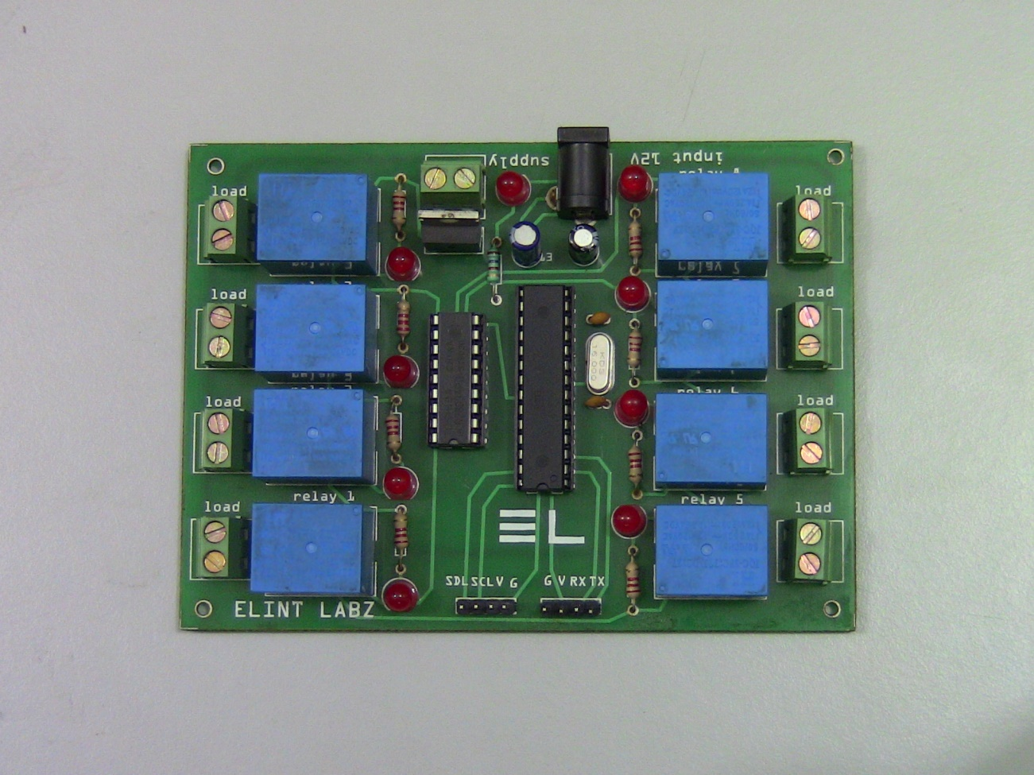

Connect load to the load terminal and provide 230V AC supply to the supply port. Current flowing through the coil of the relay creates a magnetic field which attracts a lever and changes the switch contacts. The coil current can be on or off so relays have two switch positions and they are double throw (changeover) switches.